Homework5 for GPI

1. KK 4.3 (5.3)
2. KK 4.5 (5.5)
3. KK 4.7 (5.7)
4. KK 4.9

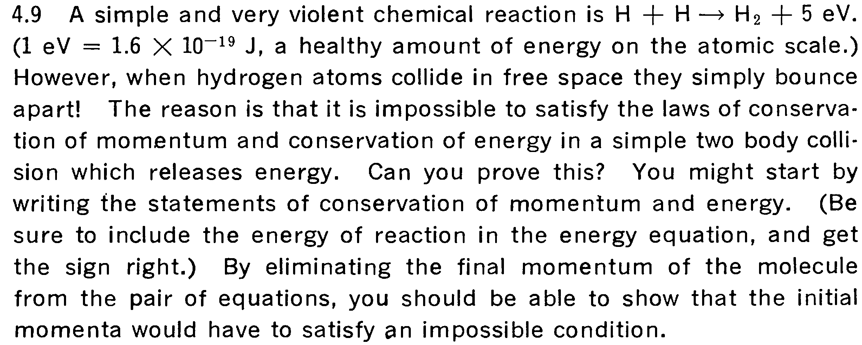

1. KK.4.10 (5.9)
2. KK 4.11 (5.10) (this is basically a Momentum-Impulse problem)
3. KK 4.13 (5.12)
4. KK. 4.15 (5.14)
5. KK 4.17 (5.16)
6. KK. 4.20 (5.18)
7. KK.4.21 (5.19)